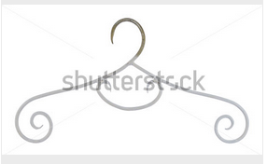

Zoek: kledinghanger

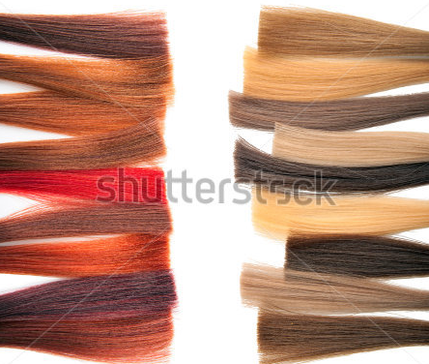

zoek: Styling

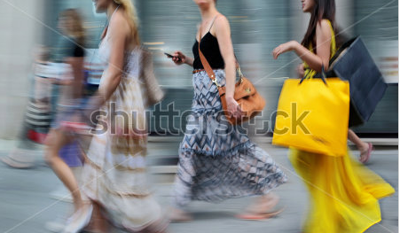

Zoek: Styling

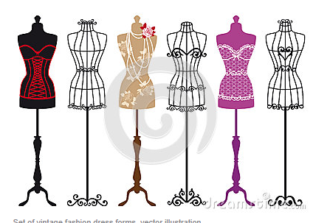

http://www.dreamstime.com/stock-photography-vintage-fashion-mannequins-vector-set-image26810302

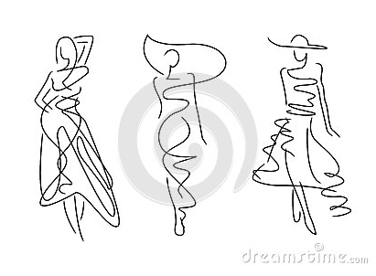

http://www.dreamstime.com/royalty-free-stock-image-sketch-fashion-poses-hand-draw-image34786456

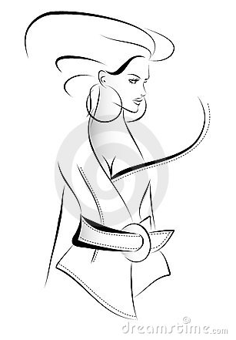

http://www.dreamstime.com/stock-photo-fashion-sketch-image11705660

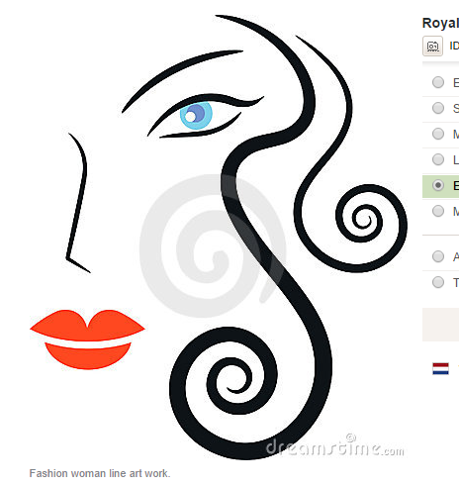

http://www.dreamstime.com/royalty-free-stock-photography-fashion-woman-image14723097

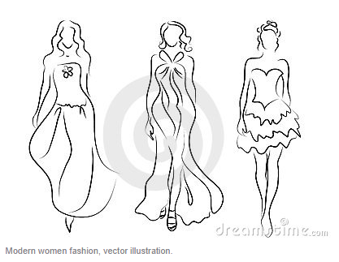http://www.dreamstime.com/stock-photos-women-fashion-image10684213

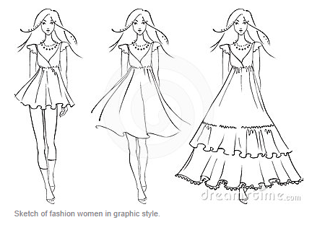

http://www.dreamstime.com/royalty-free-stock-photos-fashion-models-dresses-image24308798

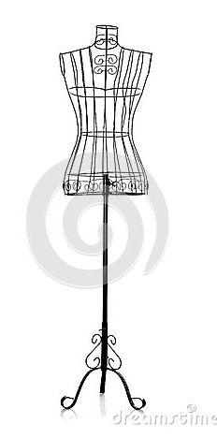

http://www.dreamstime.com/royalty-free-stock-image-iron-clothes-hanger-image25576006

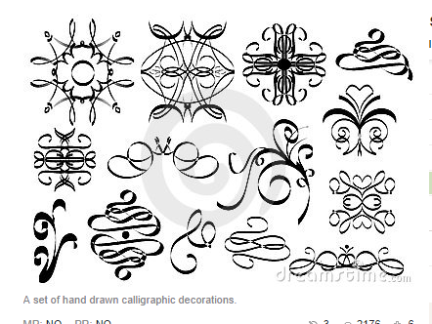

http://www.dreamstime.com/stock-images-calligraphic-ornaments-image13638144

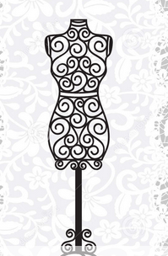

http://www.dreamstime.com/royalty-free-stock-images-mannequin-chandelier-lace-background-image27644329

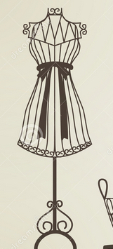

http://www.dreamstime.com/stock-photography-mannequin-sillhouette-vector-file-eps-image31191612

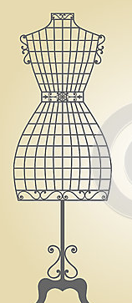

http://www.dreamstime.com/royalty-free-stock-images-vintage-mannequin-sewing-machine-vector-wooden-wrought-iron-floral-frame-image32859619

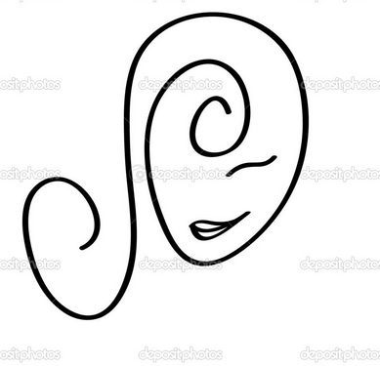

http://nl.depositphotos.com/6666625/stock-photo-curly-girl.html?sst=180&sqc=206&sqm=4637&sq=43yv1z

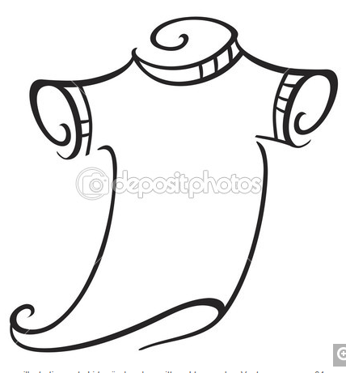

http://nl.depositphotos.com/6440548/stock-illustration-t-shirt.html?sst=480&sqc=488&sqm=4637&sq=43yv1z